**4 Real Prints**

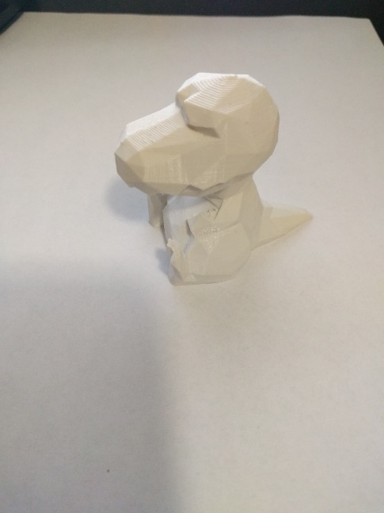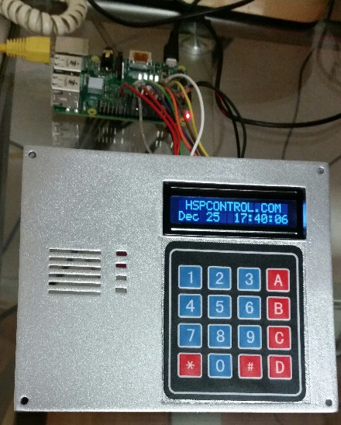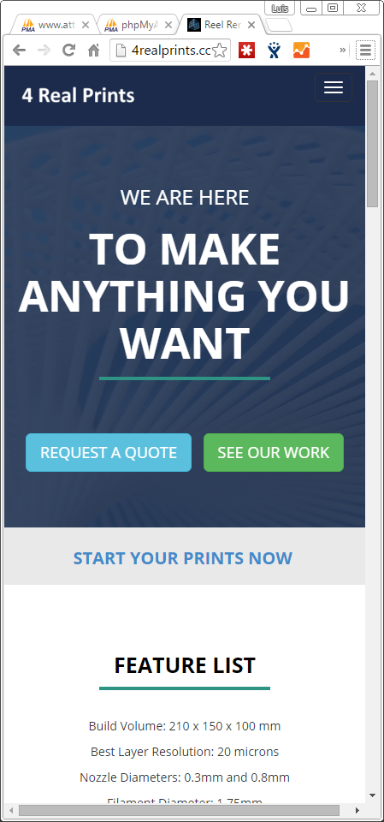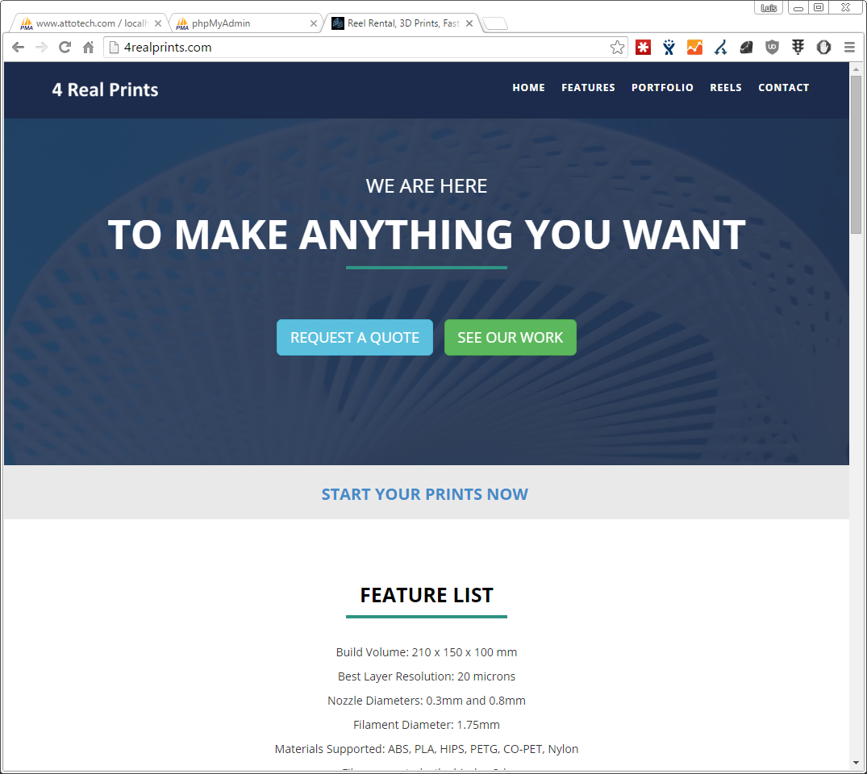

This website is for my private on the side 3D printing sales. I run prints for customers but I decided I needed a website. I created this website with images, contact form and more in under a few mins. SEO ready and completely mobile.